Cleaner Training, understand your backings and toppings!

Please watch these videos and then read below.

[Removing Tearaway](https://youtu.be/9C9KewzyV1c) (https://youtu.be/9C9KewzyV1c)

[Removing Cutaway Backing](https://youtu.be/6M1MzdfgMRY) (https://youtu.be/6M1MzdfgMRY)

[Getting Rid of Hoop Marks](https://youtu.be/8f8IHizhYvM)

[Tear Away and Water Soluble Topping](https://youtu.be/NCD58La26hg)

[Cleaning 3D Embroidery](https://youtu.be/v3u282HugW8)

These are the topping you will find on the garments and how to remove them!

Tear away (E-ZEE Tear Crisp 1.8)

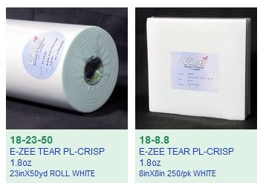

Tear away is exactly as it sounds, you hold the garment it one hand and tear the backing off. Around certain corners it might not tear clean off and you will need to remove the pieces by picking at it. Tear away might be used by itself if a garment is non-stretchy or if a garment is stretchy - tear away can be used behind a cutaway backing.If this is the case, tear the tearaway off first then cut the cutaway from the garment. If two tear away backings are used, do not pull both off at the same time, pull one off and then the other!

Hat tear away (EZEE Cap 2.5)

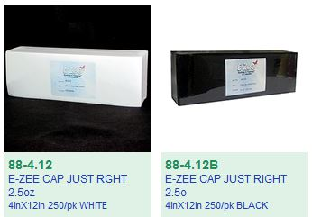

Hat backing tears away just like the garment tear away backing but is slightly thicker.

Cleaning cutaway backings should be done with large fabric scissors. Hold the cutaway backing in one had and the scissors in the other. Cut the tearaway backing about an ⅛ inch away from the embroidery.

Types of backing you might see:

Thin Mesh (EZEE Weblon Noshow)

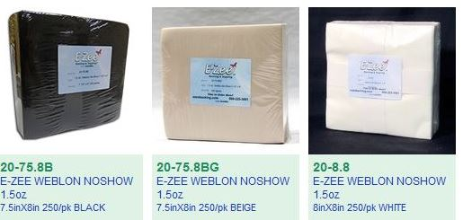

Woven Cutaway (EZEE Cut Performance)

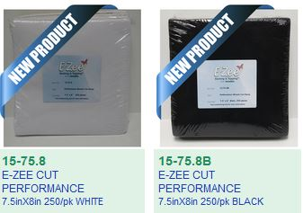

EZEE CUT 2.5 Just Right

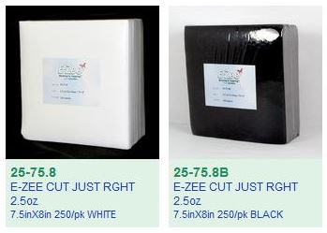

**Again a reminder**

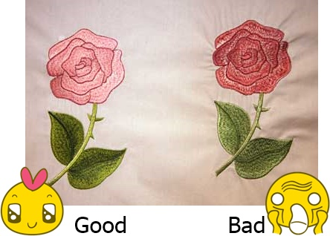

If you see embroidery with puckering, try steaming it to see if that relaxes the fibers and the wrinkles go away. IF steaming doesn’t fix it, put it to the side for a manager to review.

**We do not want to send puckered embroidery to a client.**

If the next thicker backing causes an “embroidery badge”, put to the side for a manager’s review.

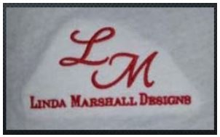

**We do not want to send ugly embroidery to a client.**

If embroidery has stray lines (bad registration), try picking the stitches out if it's a small error. If it takes more than 2 minutes to try to fix, put it to the side for manager review.

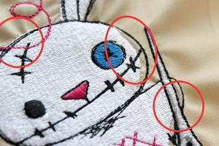

**We do not want to send bad embroidery to the client.**

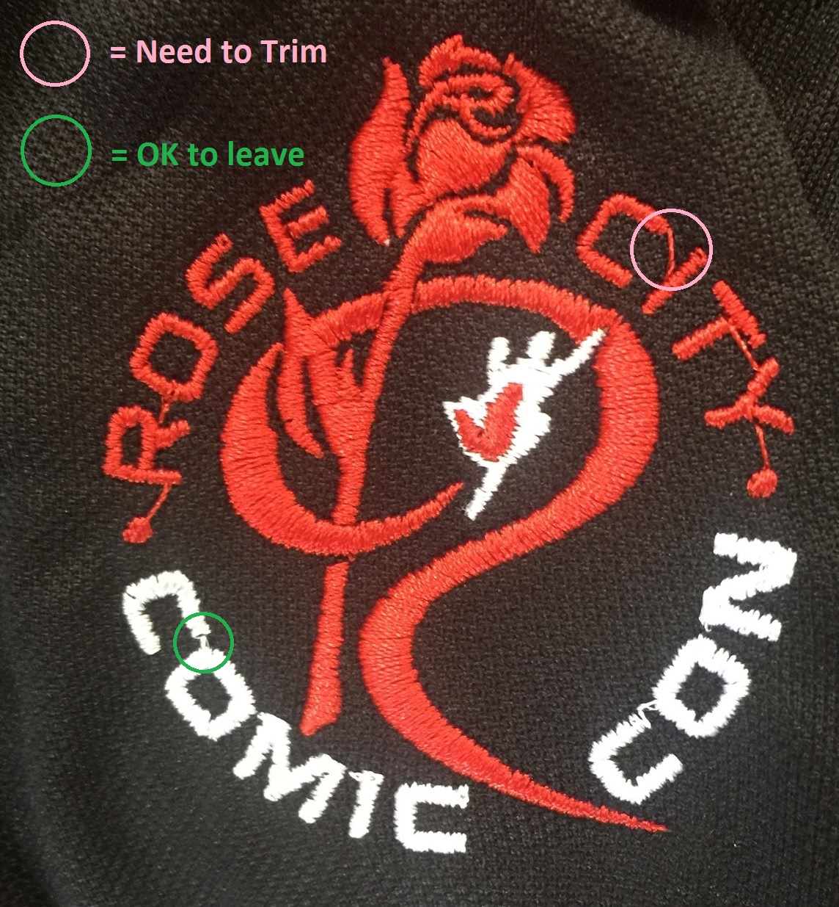

Please read [this article](https://www.seasonedhomemaker.com/day-19-jump-stitches/) on identifying Jump stitches that need to trimmed versus a running stitch between small letters. Cuts in embroidery slow down production (by 6 seconds every cut), so the digitizer will either leave small stitches between tiny gaps that are not intended to be trimmed, OR to save time, will leave stitches with a large gap with the intention that you will trim it after the design is finished running. If a thread looks long enough to get a pair of scissors under and trim - you should do so.

Water Soluble Topping (E-ZEE AQUA SUPREME)

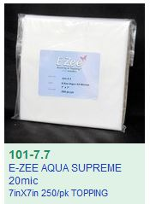

This topping will first be torn away and then you can melt the tiny pieces away with water. Use a steamer or water bottle to moisten the topping. Rub the remaining topping away with a ball of the topping, a coffee filter or a toothbrush.

3mm Foam (Do not use craft foam from craft store)

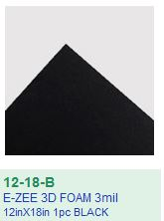

3D embroidery requires you to tear away the outside foam and then use a heat gun on the tiny pieces that stick out from the embroidery. The heat gun should stay 6 inches away from the embroidery or the polyester thread will melt and char. Sometimes larger pieces of foam need to be poked back inside the embroidery with the point of the scissors or tweezers if it's too large to melt away.

Sometimes hoops will leave a mark where it clamped the embroidery.

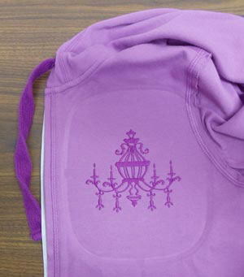

Remove this imprint by steaming the garment. The hoop mark will fall out. You can also spray it with water and rub the garment with another piece of fabric. **Do not send garments to clients with the hoop impression.**